✅ Lab 3 — Looping Structures in C++

Objectives
By the end of this lab, you will be able to:
- Use for, while, and do…while loops.
- Implement counter-controlled, sentinel-controlled, and flag-controlled loops.
- Apply loops to real computational problems.
- Use break and continue to control loop execution.
- Practice debugging loop errors.

Part 1 — for Loops
Question 1
Write a program that prints numbers from 1 to 10 using a for loop.
Answer:
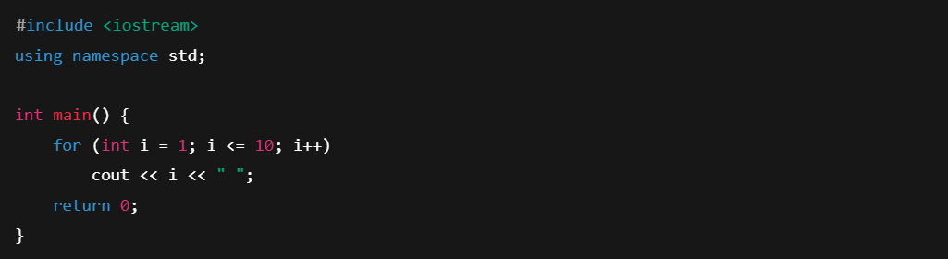

Question 2
Print the sum of integers from 1 to 100 using a for loop.
Answer:
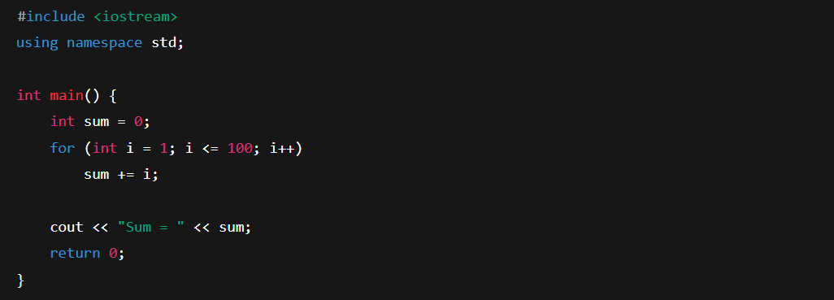

Part 2 — while Loops
Question 3
Write a program that asks the user to enter positive numbers.
Stop when the user enters 0, then print the total sum.
(This is a sentinel-controlled loop.)
Answer:

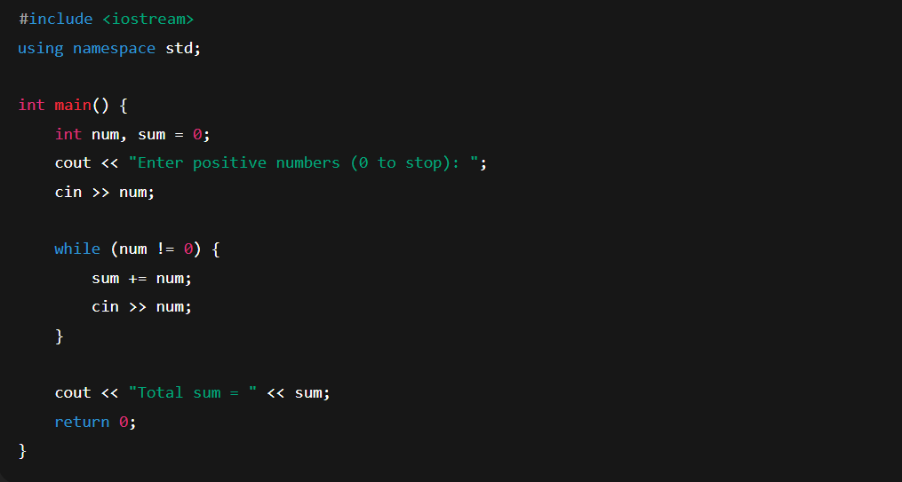

Question 4
Write a counter-controlled loop that asks the user to input 5 numbers and prints the average.
Answer:
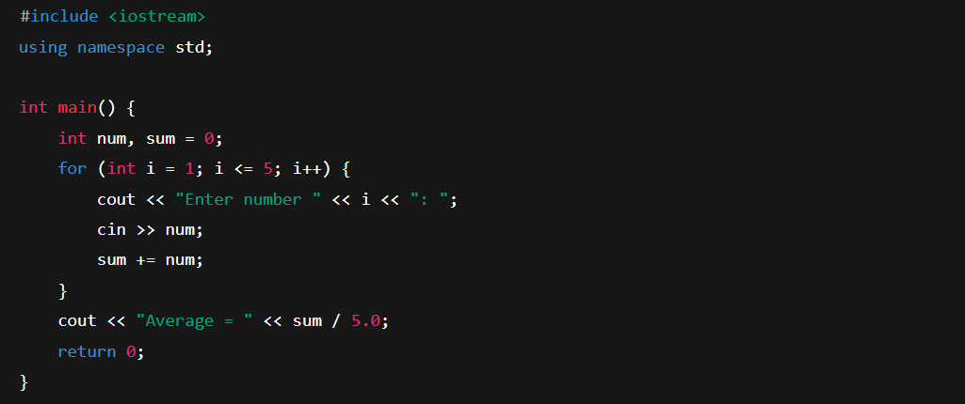

Part 3 — do…while Loop
Question 5
Write a program that repeatedly asks for a password until the user enters 1234.
Print “Access Granted.”
Answer:
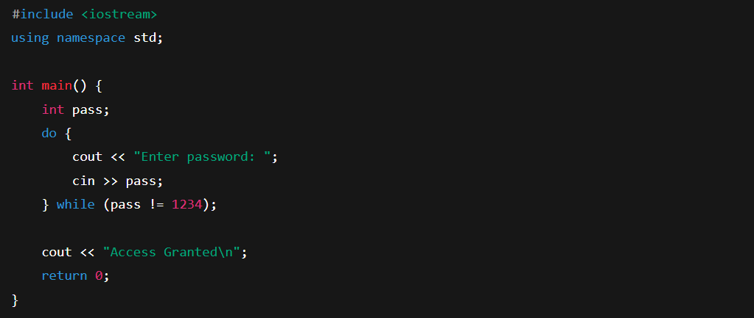

Part 4 — Debugging Loops
Question 6
What is wrong with this loop?
Answer (Explanation):
- The loop uses i-- which moves away from the stopping condition.
- It produces an infinite loop.
- It should be:

Part 5 — Using break and continue
Question 7 — Using break
Write a program that asks the user to enter numbers.
Stop immediately when the user enters a negative number, then print “Loop stopped.”
Answer:
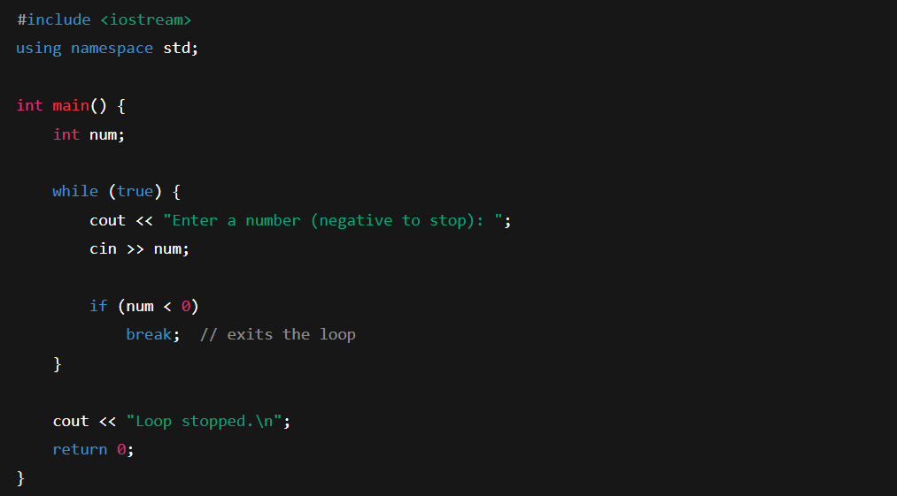

Question 8 — Using continue
Write a program that prints numbers from 1 to 10, but skips printing the number 5 using the continue statement.
Answer:

